Pymaceuticals Analysis

* 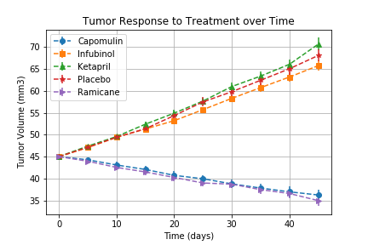According to the Tumor Response to Treatment graph, Capomulin was the only drug that decreased the tumor size over the 45 day period. If looking at the DataFrame as well, Ramicane is another drug that decreased the tumor size as well. On the otherhand, most drugs did not have a significant response when comparing the treatment to a placebo given to the mice. Some drugs, such as Ketapril, increased the size of the tumor.
* A close up of a map

  Description automatically generatedWhen looking at the Metastatic sites during the treatment process, Capomulin and Ramicane again were the best candidates for treatment. Every drug had in increase in Metastatic sites, but mice with treatments in Capomilin and Ramicane spread the least. These medications help slow the spread of the cancers in the mice.
* A close up of a map

  Description automatically generatedThe runner ups for Metastic sites were Infubinol and Stelasyn. If someone look at this data alone, they might think it could be a good option. But when looking at the data alongside the survival rate data, it shows that survival rate of mice with taking this medication drop siginifcantly the longer they take this medication. According to the treatment over time data,

these medications also do not decrease the tumor size much.

* Based on the histogram, Capomulin and Ramicane had the only decrease in treatment with -19% and -22% respectively. Mice taking Ketapril on the other hand increased the tumor size by 57% which is 6% more than mice taking a placebo.

